**How to use the Billing Application**

# **How to run the app**

Please see the other document if you need to install/run the server. After you run the server, you can access the application by going to [http://localhost:8080/](http://localhost:8080/accounts/sign_in/)

You will then be redirected to a sign in page, if you are not already signed in.

Enter username and password to sign in.

Default username is: [admin@xenonhealth.com](mailto:admin@xenonhealth.com)

Default password is: Xenonhealth (capital **X**. password is case sensitive)

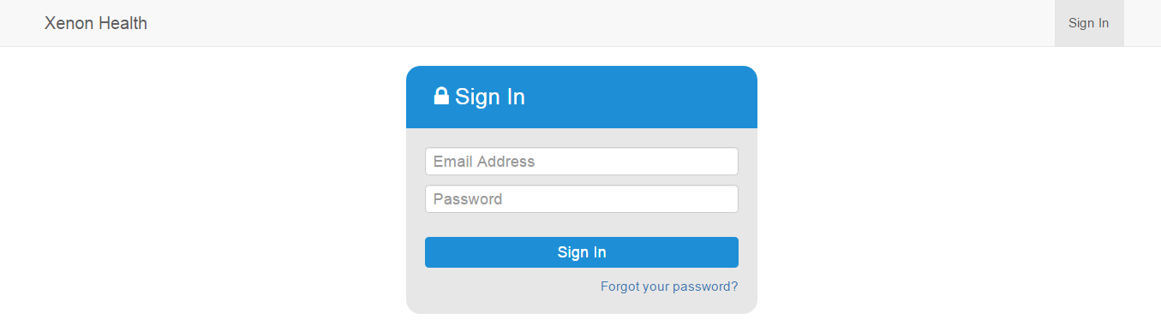

After successful signing in, you will be redirected to dashboard. This will be the main page to go to any pages in the system.

**Note**: Since this is the first time you signing in into the system, you would want to create a new username and password. To do that go to *Database -> Users -> Add user (enter your information) -> Tick Active, Staff status & Superuser status* to get access to every part of the application.

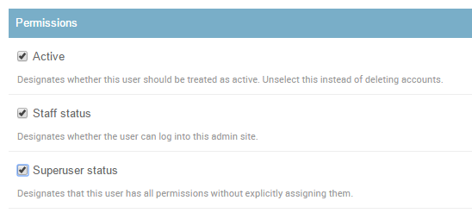

# **Dashboard**

The dashboard right now looks like this, but of course, this will eventually change to something better.

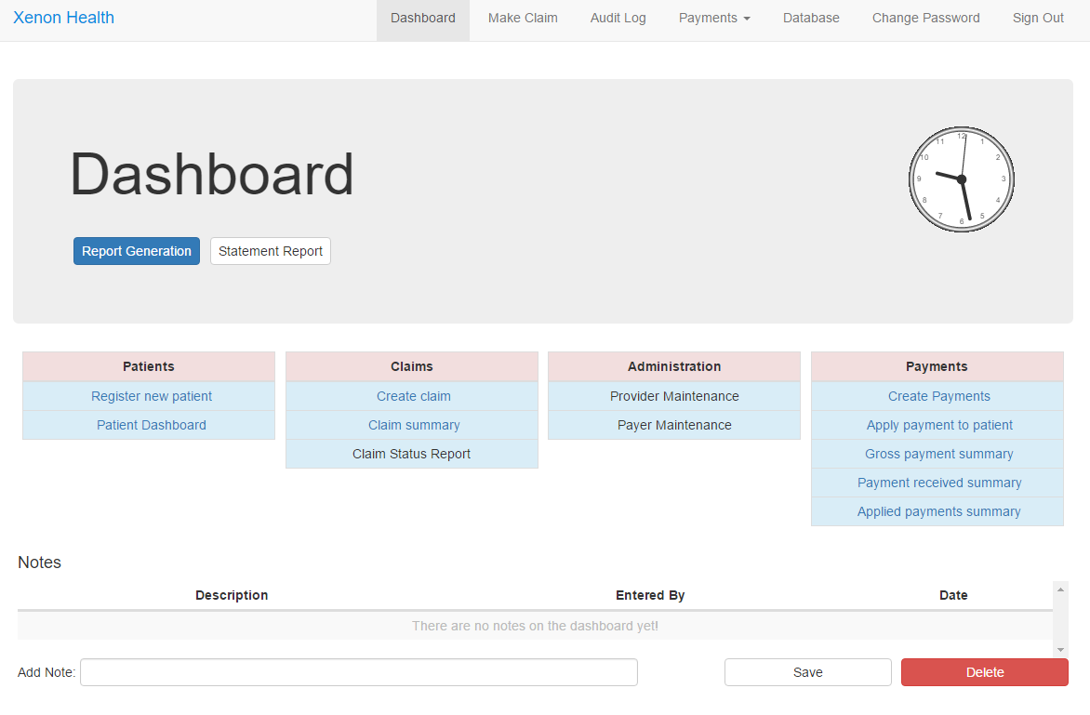

Let walk through this page and discuss all the important links that can be accessed through it.

# **Claim creation**

From dashboard page, you can click “Make Claim” on navigation bar on the top and you will be redirected to Make Claim Page.

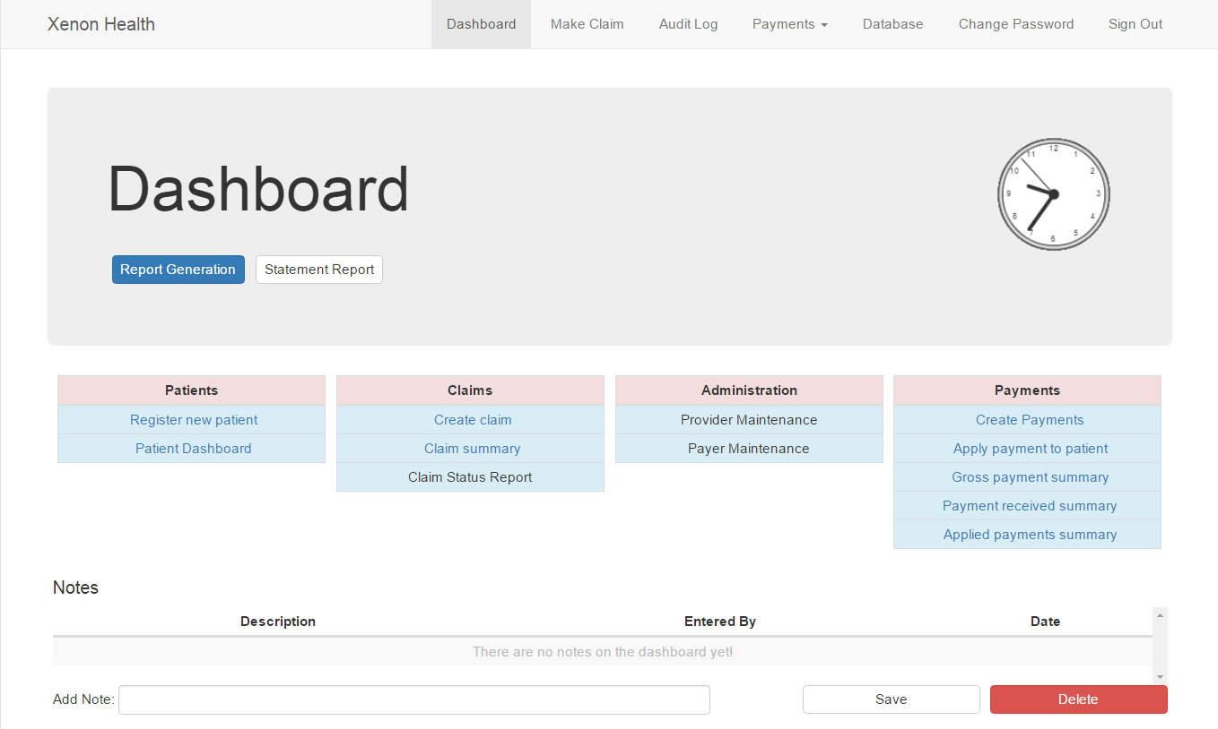

As Below picture, there will be two sub-pages you have complete in order to make a claim. You will be at “Patient & Insured Information” sub-page at first. Information about Patient, Insured, and insurance information have to be completed here.

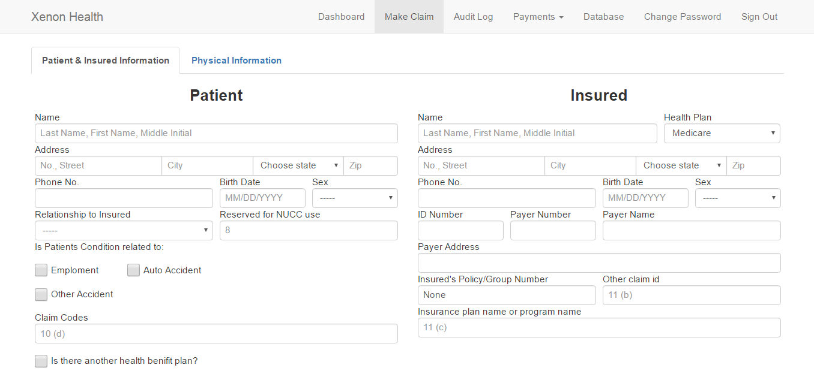

If you already have patient information in the database, there will be a suggestion list when you click at patient’s name and insured’s name. By choosing a person from this suggestion list, some other information, such as address or birth date, will be filled up automatically. The same will happen for insurance information as well.

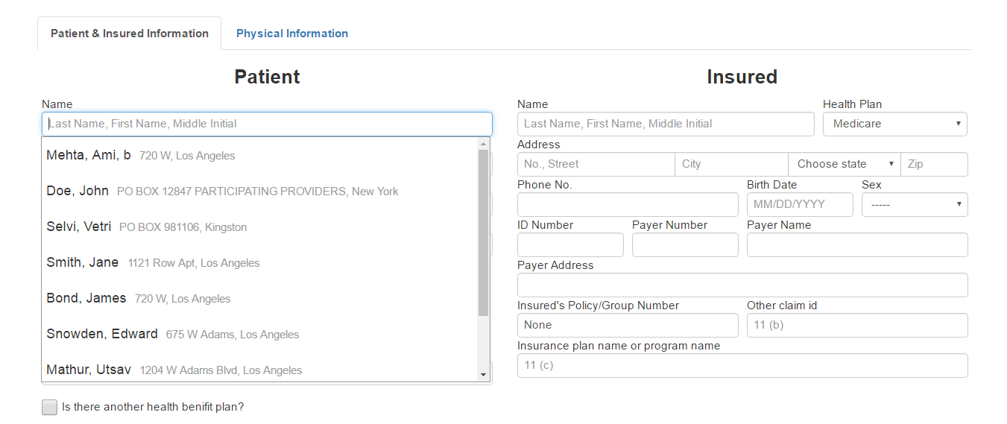

When you filled out patient information, if you select relationship to insured as “Self”, patient information will be copied to Insured automatically.

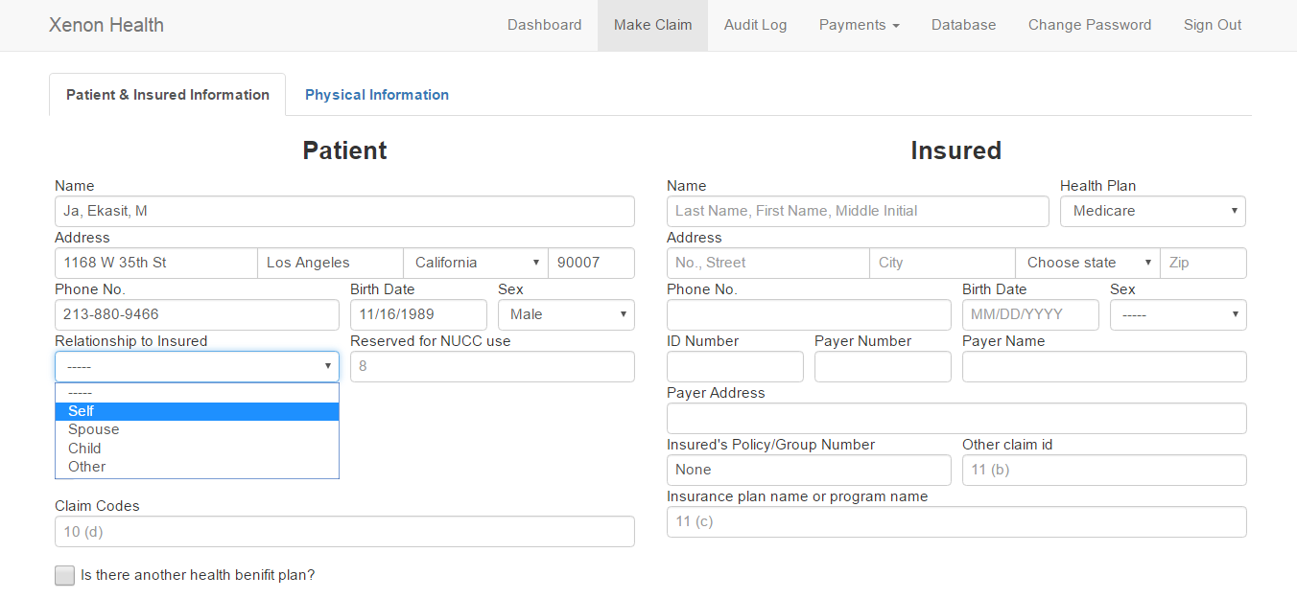

All you have left to do is to choose insurance company from insured.

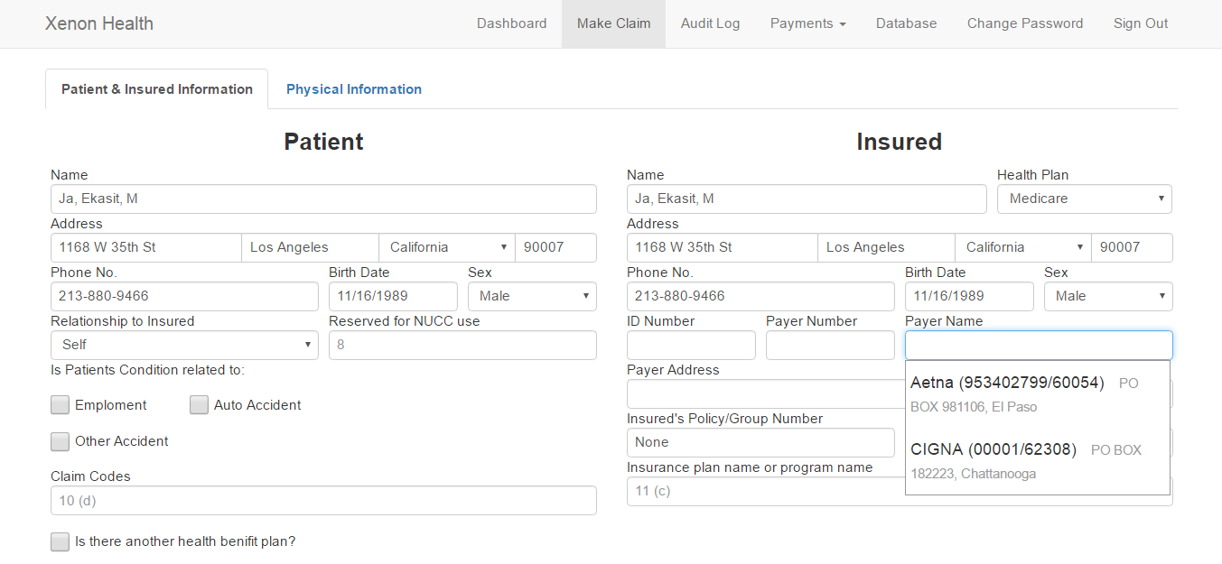

When you finished with “Patient & Insured Information” sub-page, click “Physical Information”.

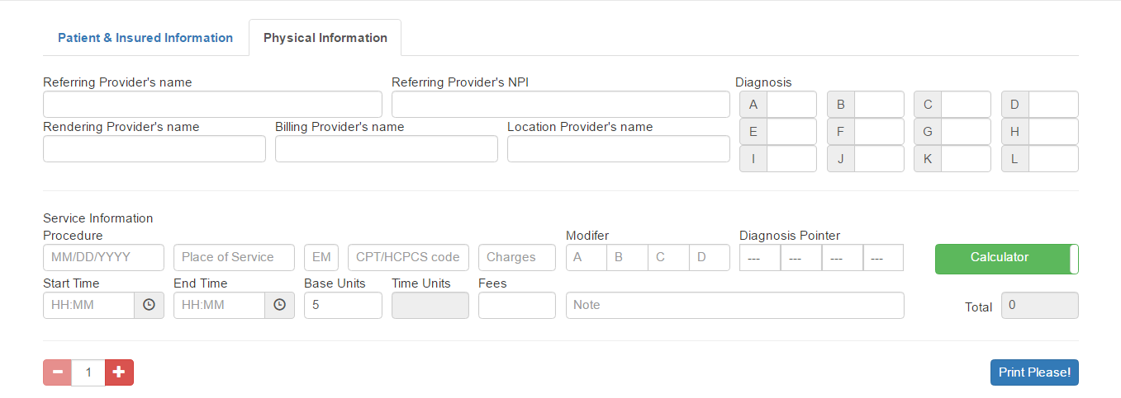

From here, you need to choose Referring, Rendering, Billing, Location provider, and information about services. You need to fill data about procedures in service information section too. Due to paper format of a claim, there can only be up to six procedures per claim. You can click at plus or minus or even change to number in between to adjust how many procedures you want to do.

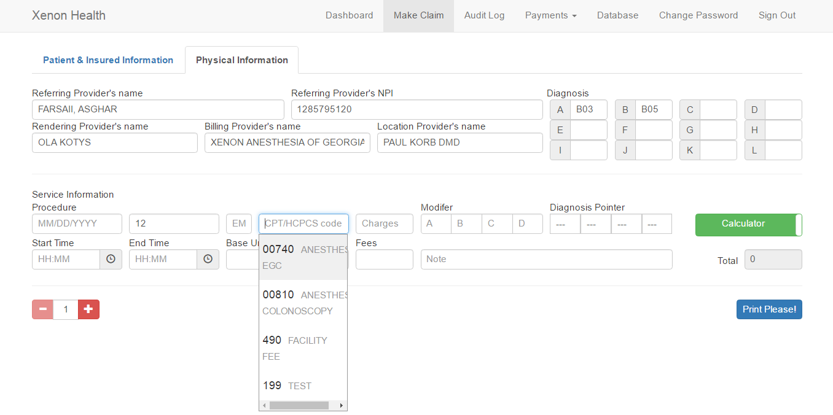

There will be suggestion list with autocomplete feature when you click at “CPT/HCPCS code” field. You can click at “Calculator” button to change additional information about the procedure to be “Drug Information” or click again to change it back.

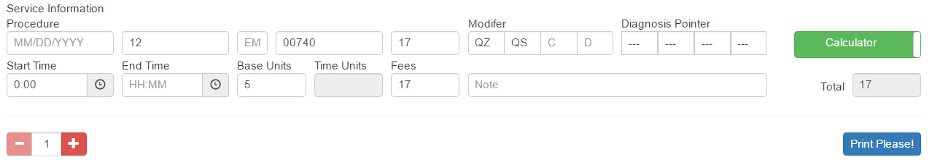

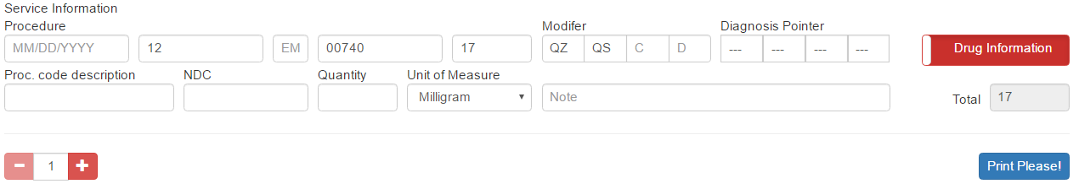

After everything is done, click “Print Please!” in this sub-page to generate the claim and new tab will be opened to display generated claim.

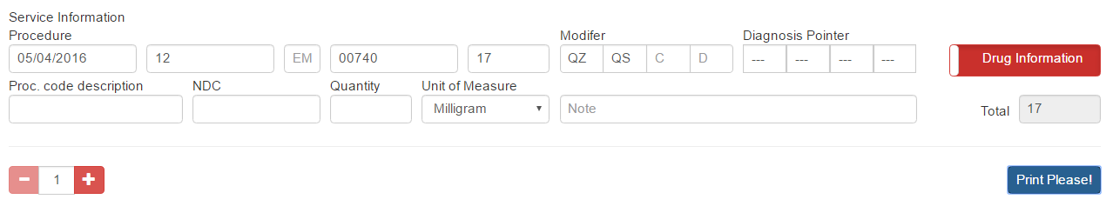

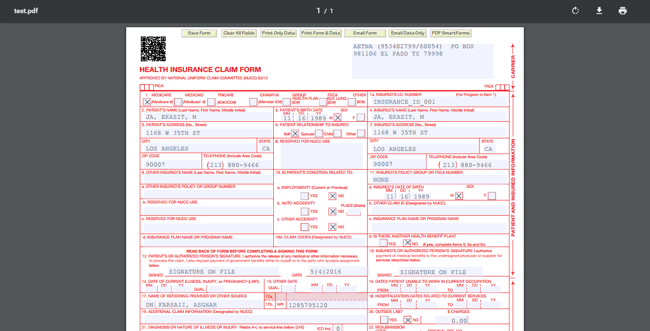

# **Patient Dashboard**

Patient dashboard is the gateway to view patient information.

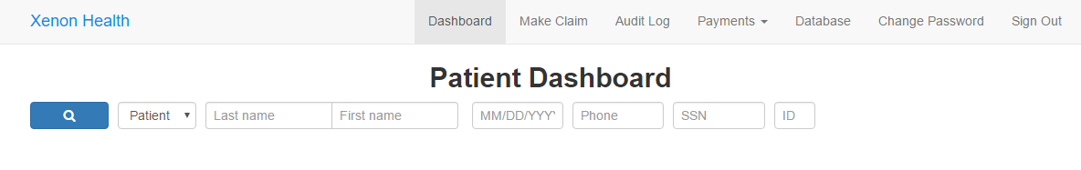

Patients can be searched by Last name, First name, date, phone number, ssn and ID. If you don’t type in any information and just click the search button, all of them will be displayed.

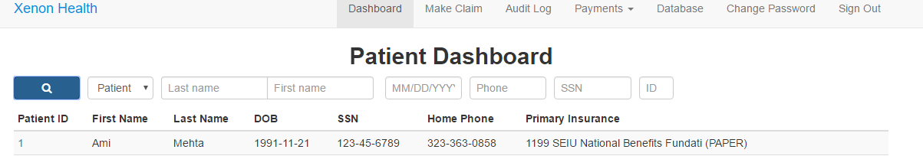

After you search for the patient, click on the Patient ID to go to the page where all information is stored of the patient. A page like the one shown below will be rendered after you click on the ID.

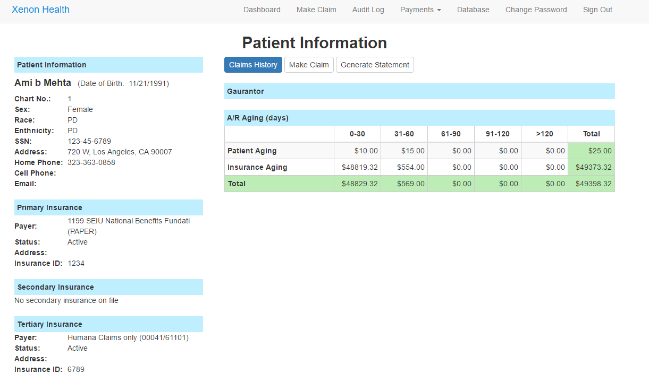

This page in divided into 9 parts. Let’s go through them one by one.

1. Patient Information: Well, as the name suggest, this displays out information about the patient, like name, sex, phone number etc.
2. Primary insurance: Primary insurance information for the patient.
3. Secondary Insurance: Secondary insurance information for the patient.
4. Tertiary Insurance: Tertiary insurance information for the patient.
5. Guarantor: Guarantor information for the patient, if any.
6. Aging days: A table to show the amount sue by the patient. It’s filtered by a range of dates. Say for example, if a patient was charged $10 today, the, that would show up in the range 0-30 (since it’s been 0 days since the patient was charged)
7. Claim History: A link to view the history of all the claims of the patient. More about this later.
8. Make Claim: A link to go to the ‘make claim’ page. This link will automatically fill in the patient information section of the claim.
9. Generate Statement: A link to generate billing statement for the patient.

# **Claim History**

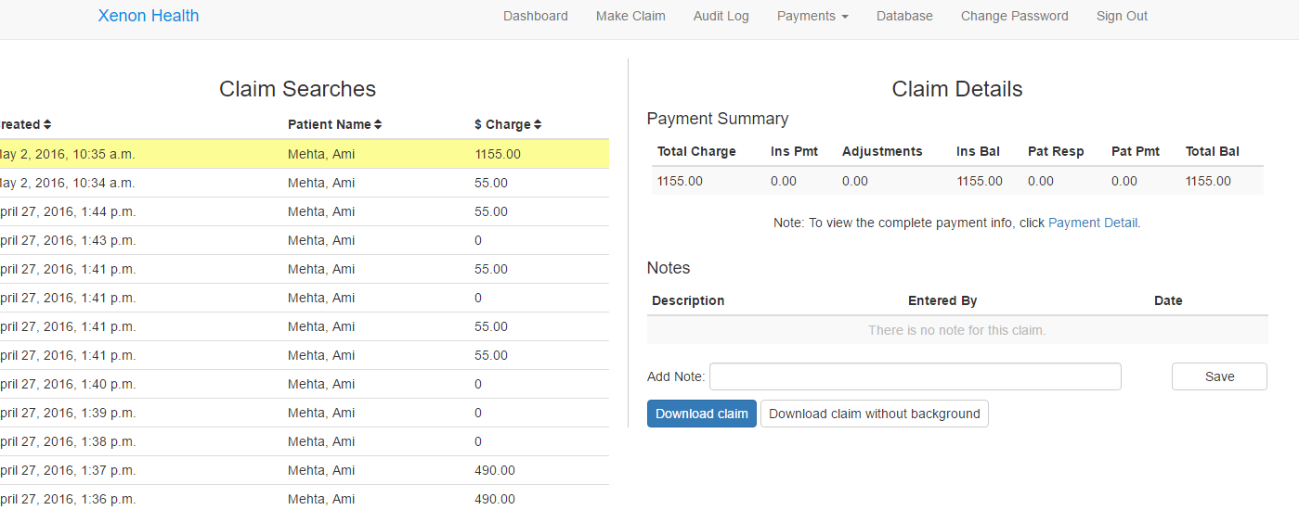

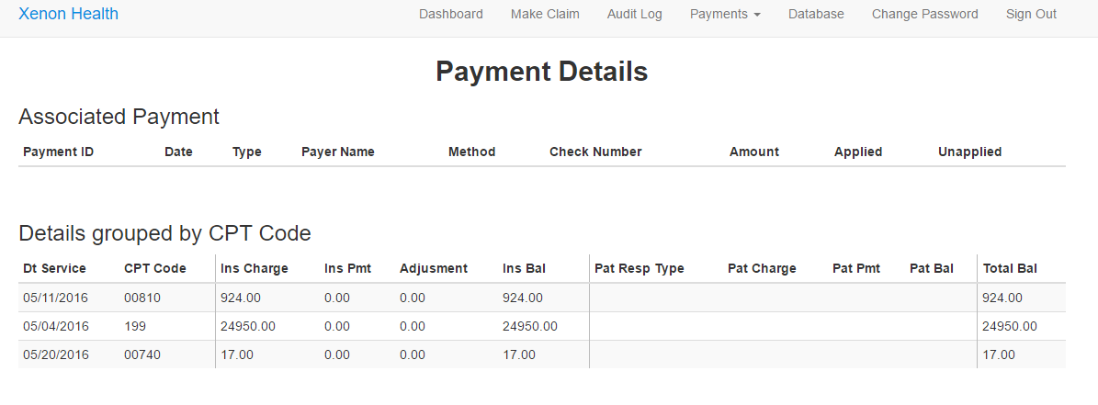

Figure 4: Payment details page

This page shows Claim Searches and Claim Details. It’s pretty self-explanatory, on the left you have list of claims that were generated previously (sorted by date), and on the right there is payment summary, which shows the summary of payment for the selected claim. Below that there is a provision to add notes for a claim. There is also a Payment Detail link which shows a more detailed information for the patient. There are also two link to download the claim with and with background. Usually, the claim with no background is used where printing is required. Screenshots for them are shown below.

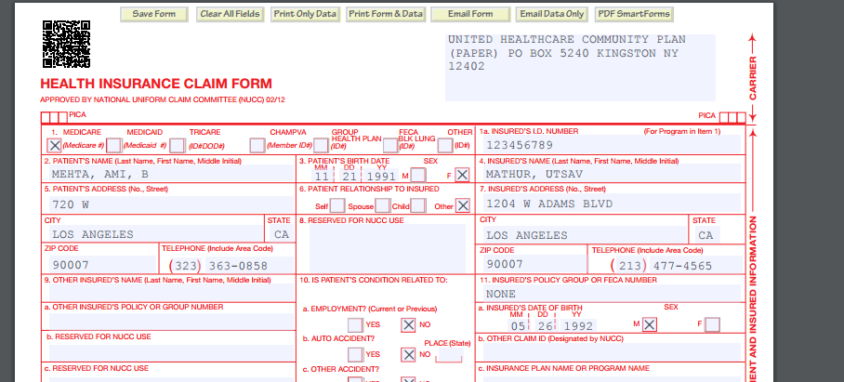

Figure 5: Claim form with background

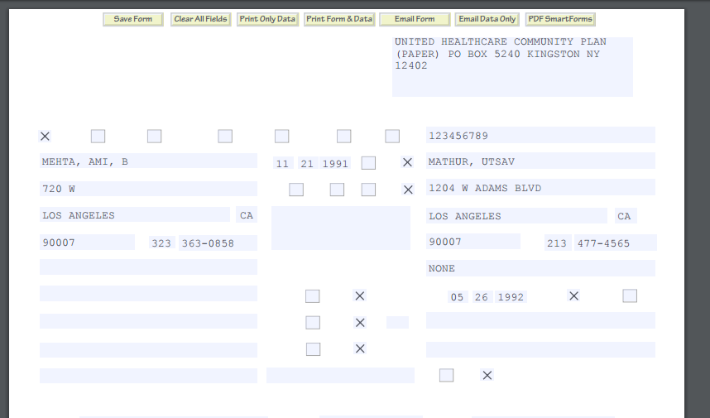

Figure 6: Claim form without background

**Tips**:

* Click on the column heading to sort the tables.
* Click on Payment Details if you want to view accounting for individual procedures.

# **Create Payments**

From navigation link, move your mouse over payment and sub-menu will be showed. From there, click create payments.

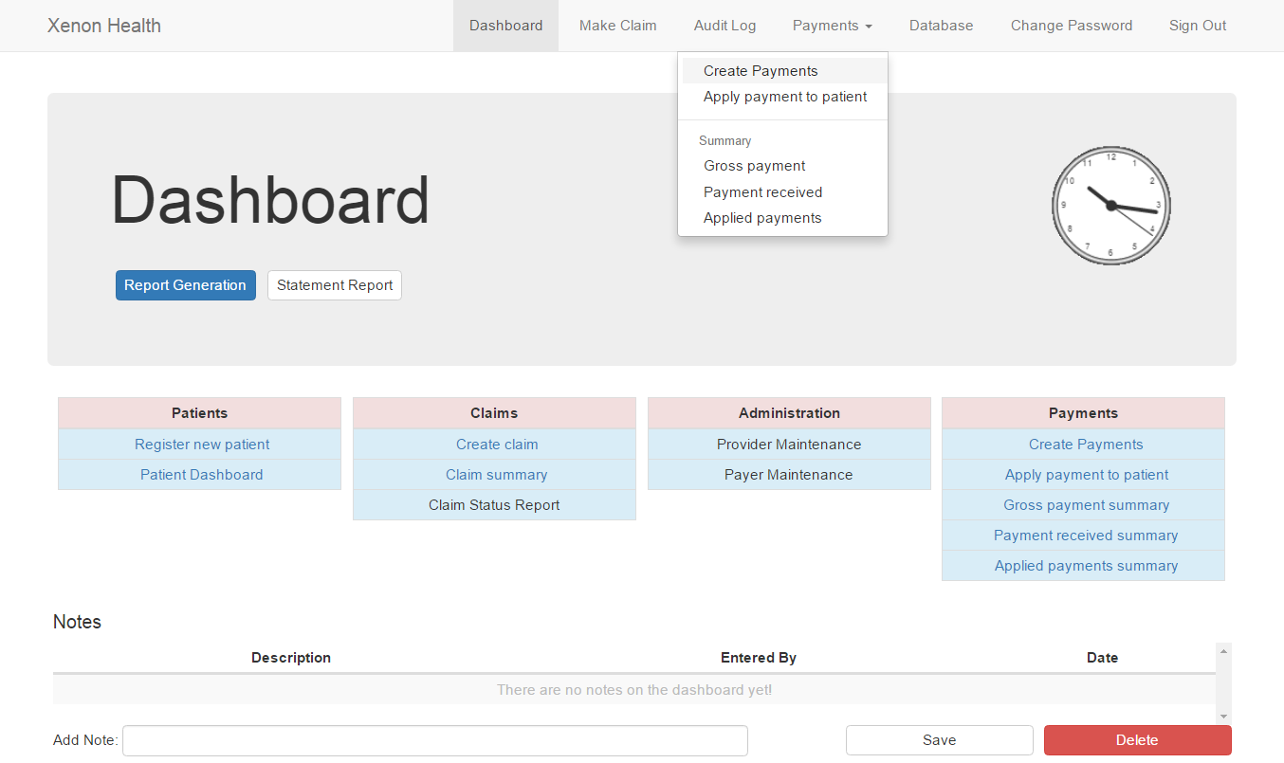

You will be redirected to Make Payment Page. Red asterisk indicates required information in order to record a payment.

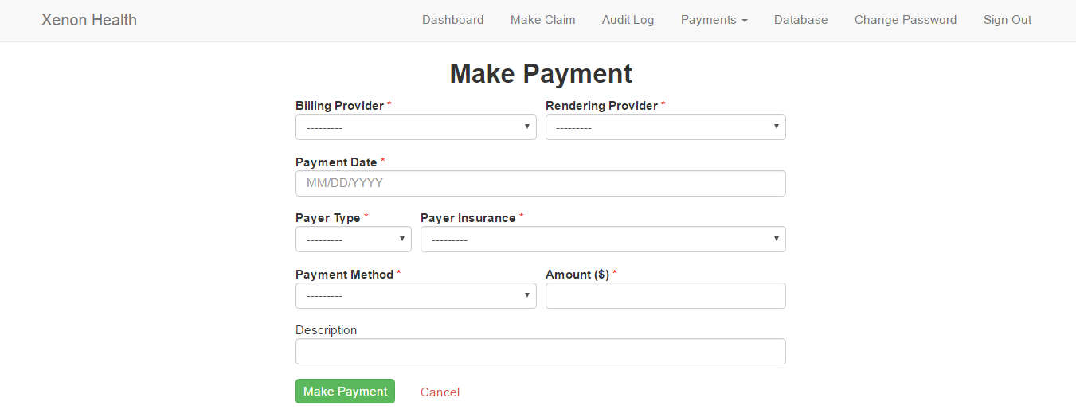

# **Create patient charge**

From “Apply Payment Charge”, click “Create Patient Charge” button and you will be redirected to the page.

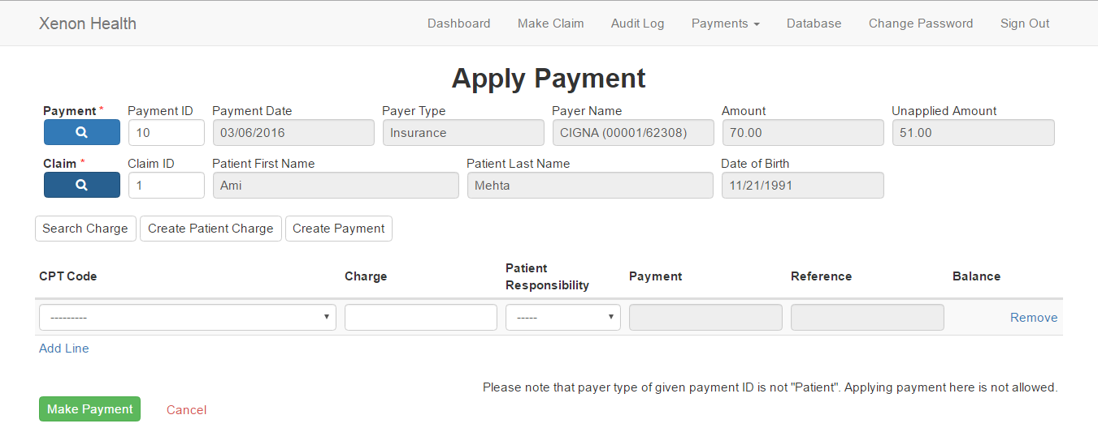

From here, you can choose procedure of that claim and fill in amount of charge. If the payment you put is patient type, you can apply from here as well. If not, you can only record amount of charge. Click “Make Payment” to save Charges.

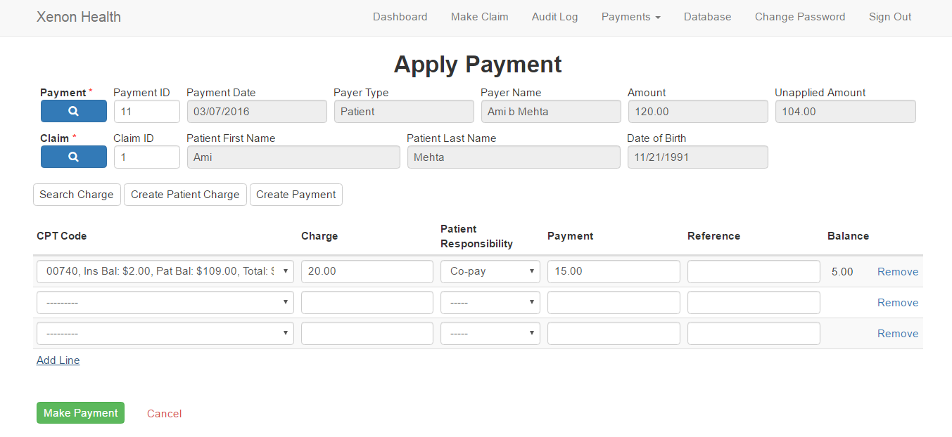

You can also click “Add Line” to create more records when you save or click “Remove” to remove that line.

# **Applying Payments**

From navigation bar, move your mouse over “payments” and click “apply payment to patient”.



You will be redirected to Apply Payment Page. Click magnifier button to search for payment and claim record.

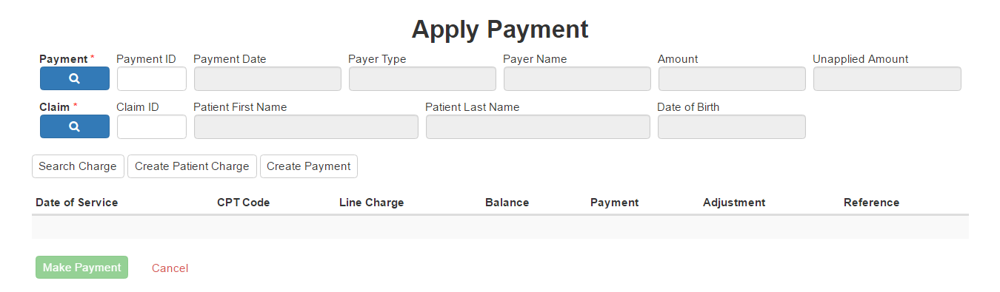

When you click magnifier button, new sub-window will be showed and you can fill some data to filter for record you want to search and click magnifier button on that sub-window to search.

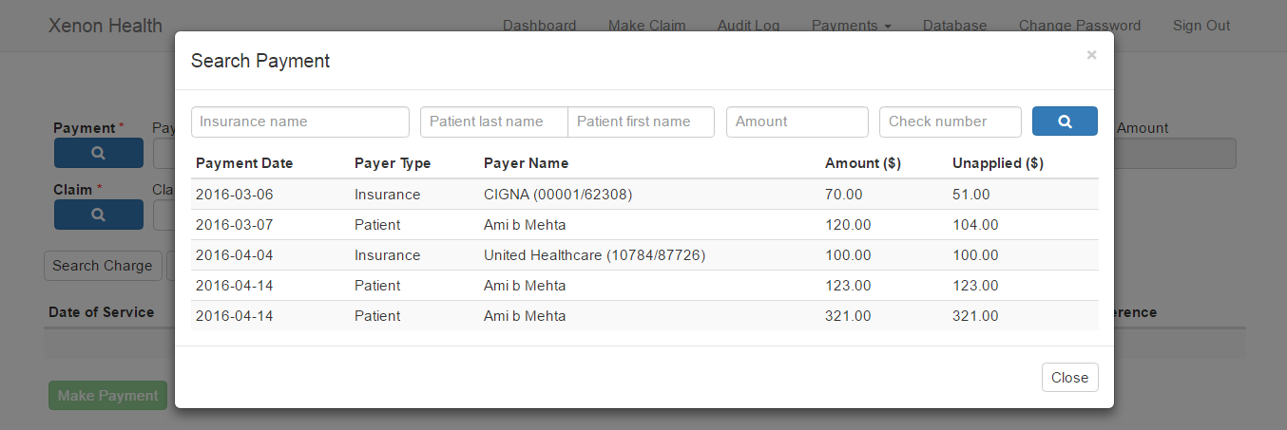

Then, list of record matching filter data you filled out will be displayed. You can click to choose that record and sub-windows will disappear. You can do the same for both “Payment” and “Claim”.

If you remember ID of payment and claim, you can simply fill it in the ID field. After everything is done, click “Search Charge” to get list of charges of that claim.

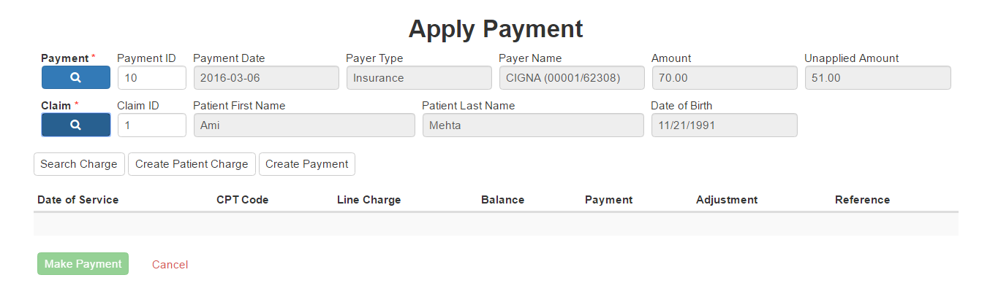

List of charges will be showed as well as notes. From here, you can fill in amount of payment you want to apply or adjustment and click “Make Payment” to save. Both insurance and patient charge will show at this point.

Note: You can do apply for charges with the same type as payment. Meaning, payment we received from insurance can be applied to only insurance charges and the same goes for patient type.

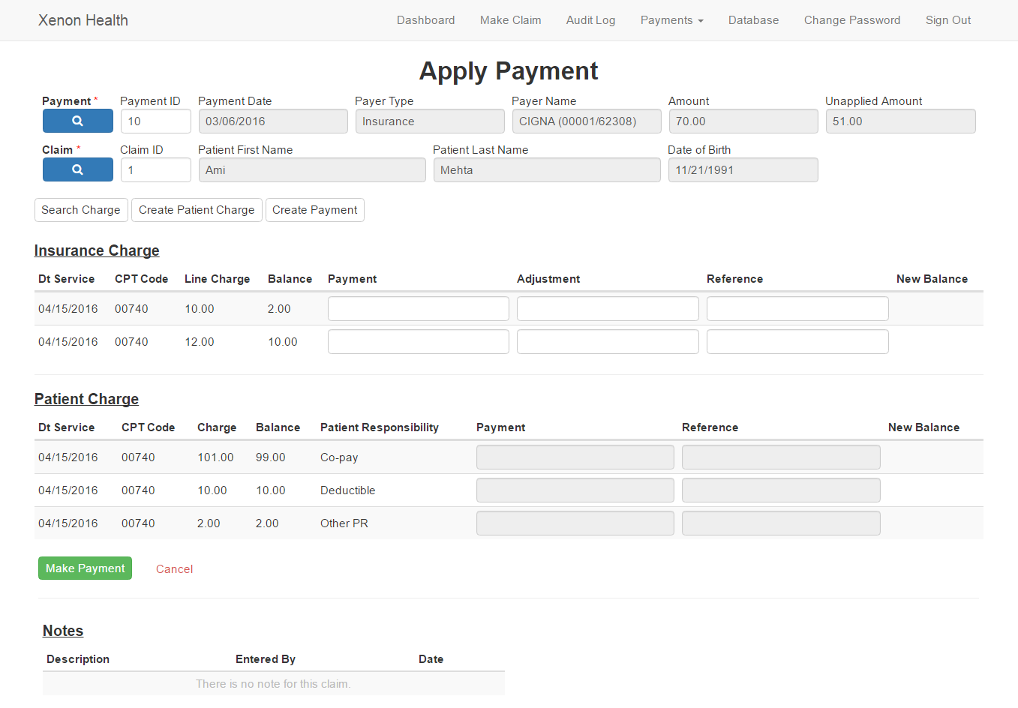

# **Report Generation**

So, the blue link on the dashboard is the place where you would click to enter report generation. Only two reports have been covered in this *– transaction report with payments* and *transaction report without payment.*

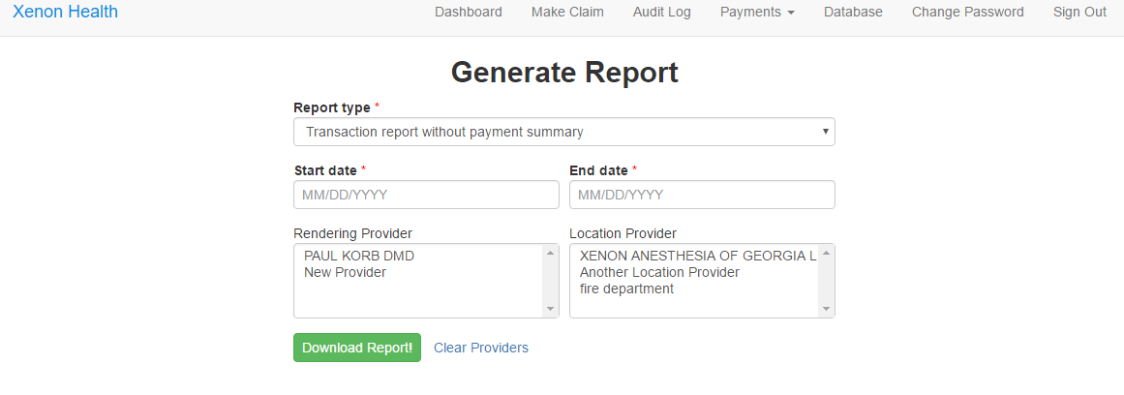

As you can see, you have a drop down to select the kind of report you want to generate. The ‘Clear Providers’ link will clear all the selected providers. When you click on ‘Download Report’, an excel workbook will be downloaded to your local machine.

**Tips:**

* If you want a report for only a SINGLE day, make the end date same as the start date.
* You can select multiple rendering and location providers.
* There are two ways to select multiple providers:
  + Don’t select anything in the box
  + Select everything in the box

Note: The start date searches for information stored in the database from 0:00 hrs of the given date and the end date searches information stored before 23:59 hrs.

# **Statement Report**

From “Dashboard”, click “Statement Report” button.

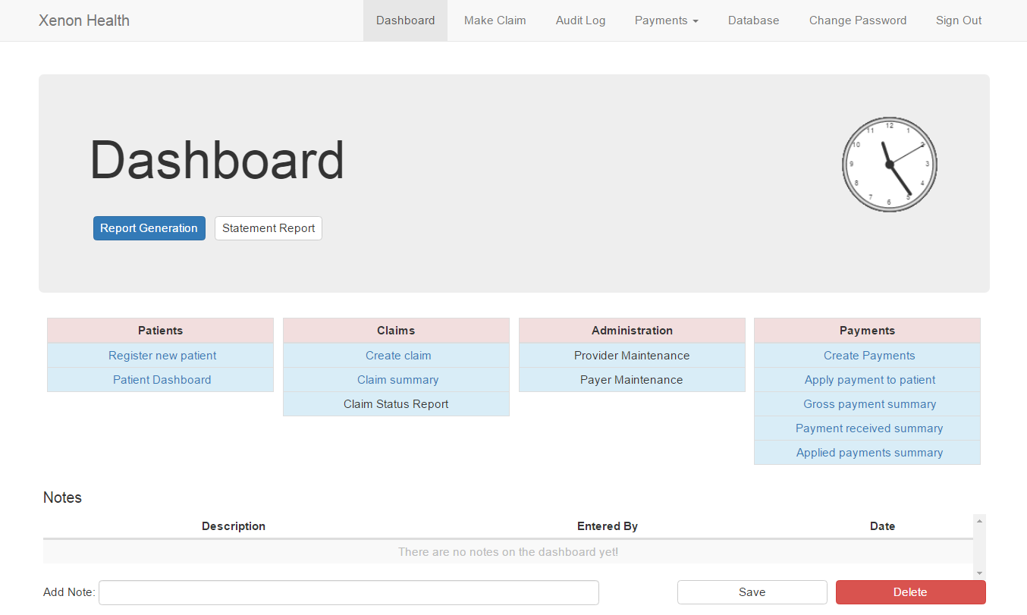

You will be redirected to Statement Report Page.

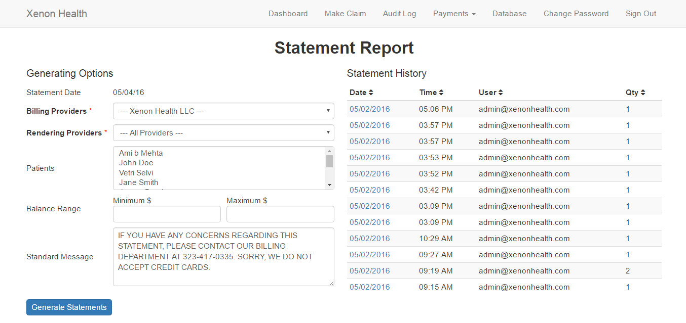

On this page, left hand side is generating option for statement report. Right hand side is a list of statement history that the system has generated so far.

Tips for generating report:

**Billing providers:** is a provider who will be showed in the report. Default is Xenon Health LLC

**Rendering Providers:** choose one and the system will generate report for claims related to that provider. Default is all rendering providers.

**Patients**: If you don’t choose any, the system will behave as you select all patients. You can choose some patients to generate report for those. Press and hold Ctrl button on the keyboard while you click patient’s name to do multi-select.

**Balance Range:** You can filter by specifying range of total remaining balance of the patient. If you don’t fill up these field. You can leave it so the system will generate any range.

**Standard Message:** is the message at the bottom of the report. If this field is empty, the default from the template will be used.

After you specify how you want to generate the report, click “Generate Statements”. This process takes time. After it is done, you will be redirected to statement history page.

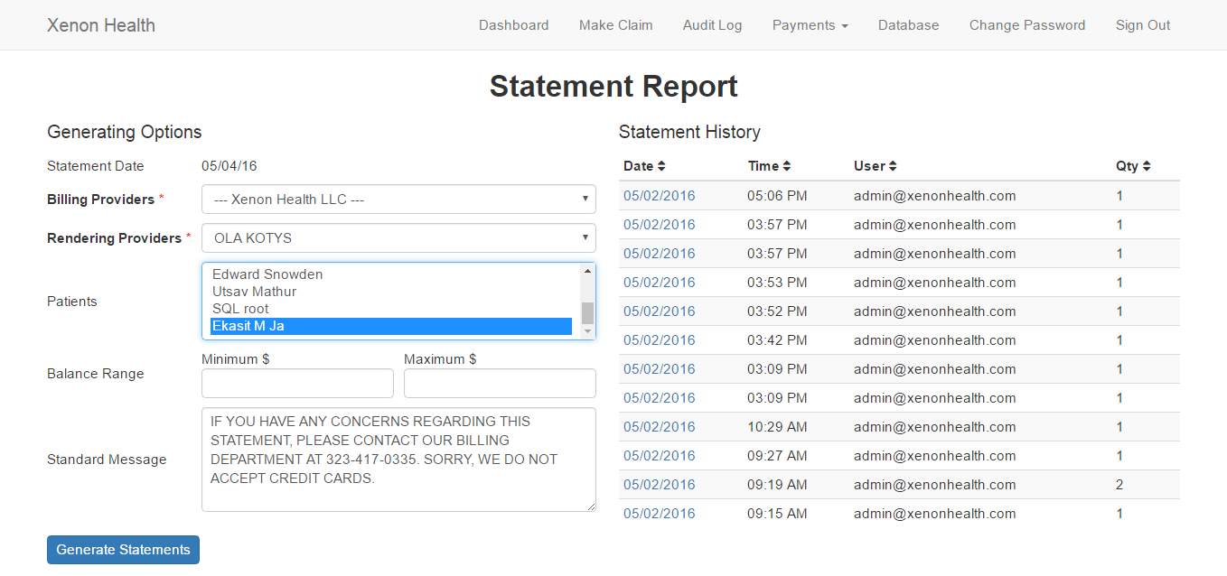

For statement history part, you can click at date column to go to the history page.



From history page, you will see all reports generated at that session. You can click at Statement ID to open the PDF file on that report.

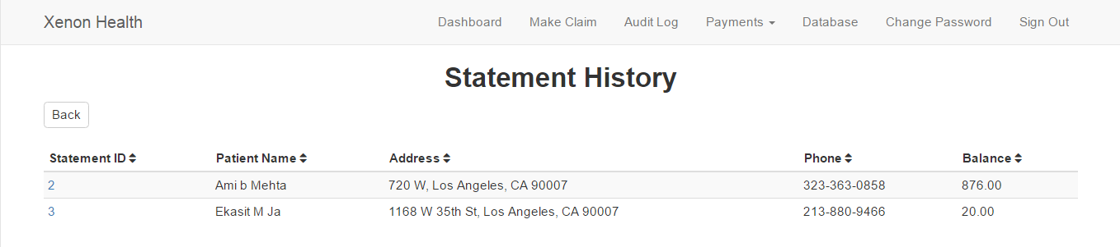

# **Audit Log**

So, as you might know the Audit Log is a HIPAA requirement and it’s a place where all changes to the database are tracked. There are two way to see the history of a record, one is thought the Audit Log page, which summarizes all changes that are made to database. It gives a good summary of OLD and NEW values. The other way to access History is by looking up the database in the Database page. After you click on any table, there will be history option on the side, which will allow you to go to an OLD sate, if necessary.

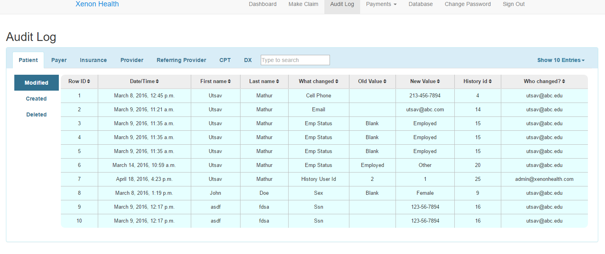

Figure 1: Accessing History from Audit Log page

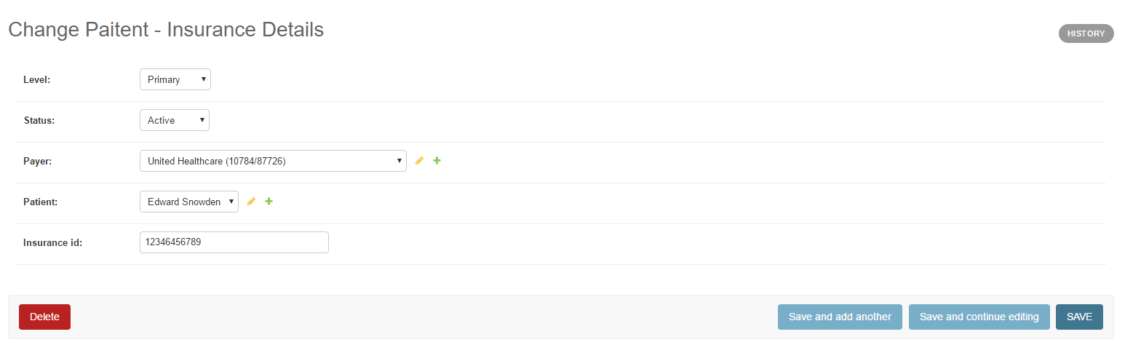

Figure 2: Accessing History from the database

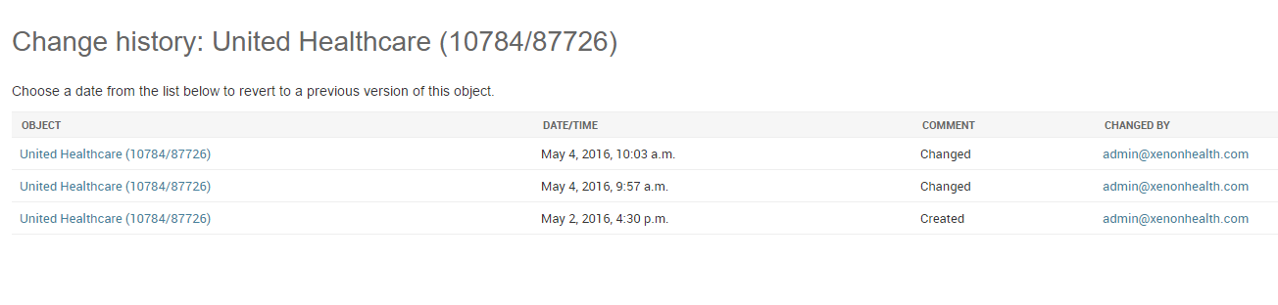

Figure 3: List of History items displayed after clicking on 'History'. To view any previous version, click on the required date and then you can revert back to that version, if necessary.

Coming back to the audit log page, as you can see, you have a list on table on the top which you can select to see the audit log of. Each table provides three choices – modified, created and deleted. As the name suggests -- modified, keeps track of all the changes to the database that has been modified; created, keeps track of the new entries to the database; and deleted keeps track of the entries that are deleted from the database.

What is important in all the tables is ‘What changed’, ‘Old Value’ and ‘New Value’ column, as these are the column which reflect the change made in the database. Additionally, there is also a ‘Who changed?’ column which records the name of the login email id that changed the state of the database.

The blank entries that you see in the Old Value column means that there was no OLD value and that this ‘What changed’ entry is new.

**Tips:**

* There is a search bar on the top which searches through all the rows of the table. It’s a very powerful search as it not only search for the exact word, but also searches texts that are part of the searched text. You can also search by date.
* Clicking on the header of a column sorts the columns. Clicking it once will sort it in the acceding order, clicking it twice will sort in the descending order.
* Searched by the person email id will list all changes made by the person in the database.
* To see the latest changes, sort the columns in descending order (click the column names twice).
* The history id is shown here so that a programmer can track all changes made to this entry in the database.

Let me walk you through with an example of how this works.

Let say you modify the insurance id someone. (Changes can be made from the database page)

Old state:

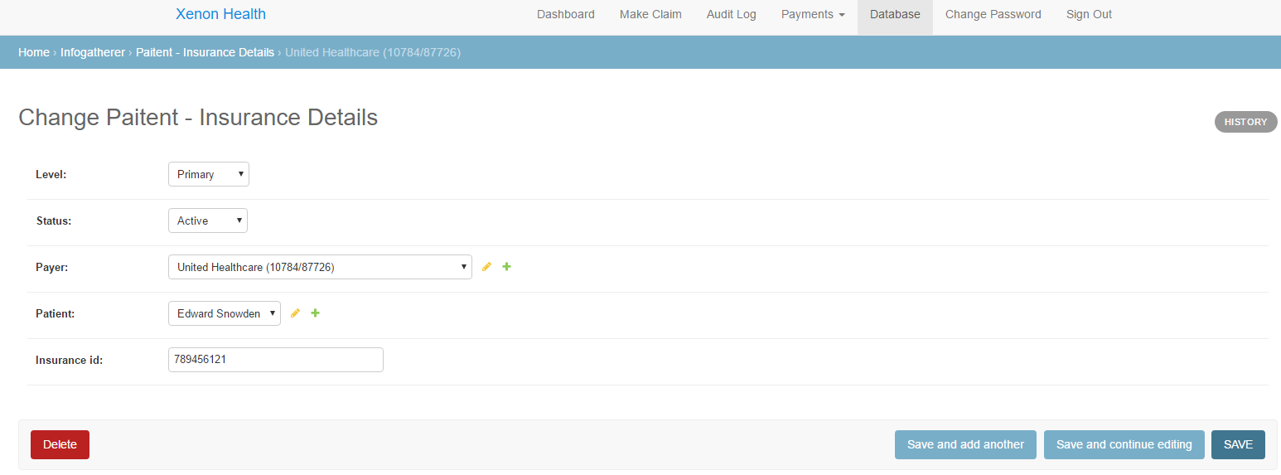

New state:

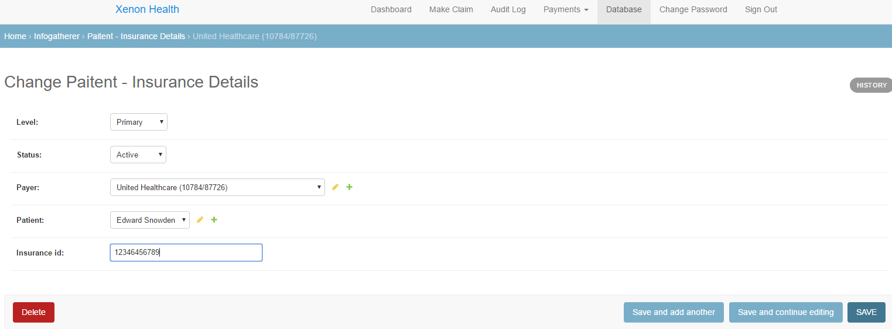

Note that I changed the insurance id.

After you save this and refresh the audit log page, you’ll see the change I made in the Insurance table (in modified section). You can also see, that I clicked the column **Date/Time** header twice, to see the immediate change to the database.

